**Two types of Email Mail notifications :  
  
Email notification steps:  
  
step1**:Goto manage Jenkins then click on configure system scroll down go the page .  
** select **Extended E-mail Notification .**\*\* under smtp server: smtp.gmail.com  
** give gmail port number **465**  in smtp port  **.  
\*\*** click on advanced setting and over there create credentials for that click on add .  
after that select **kind select as username with password** over there give your gmail username and password **.**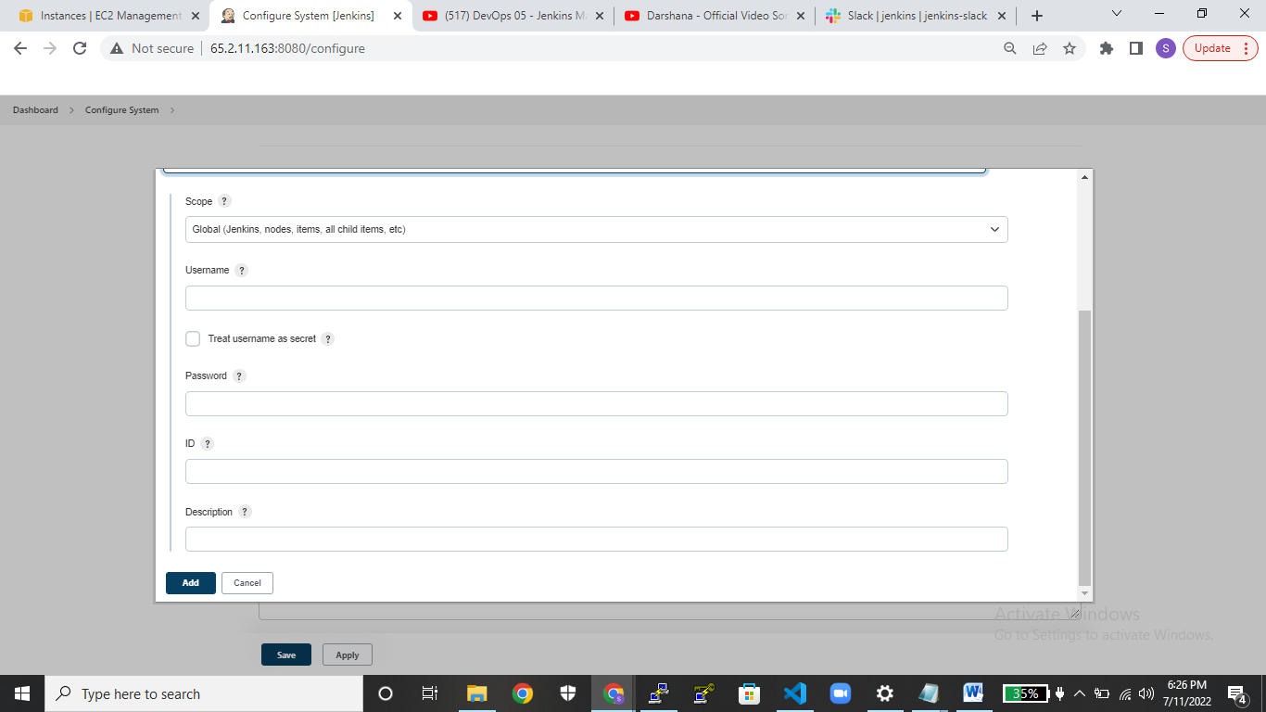  
** and then give username ubuntu and then in passphare box give the pem keyfile.  
and click on add.  
  
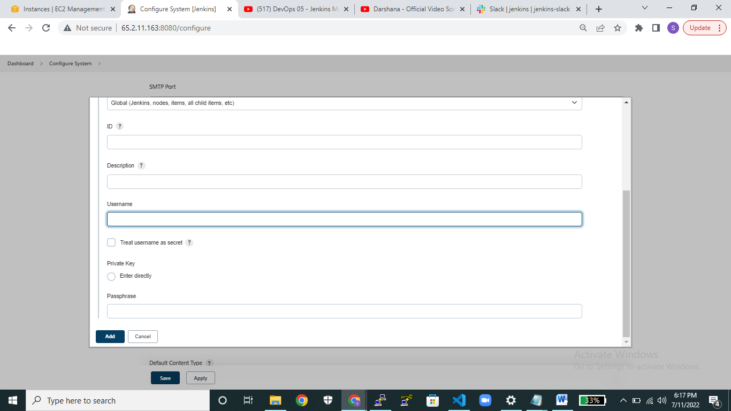

**check the use ssl   
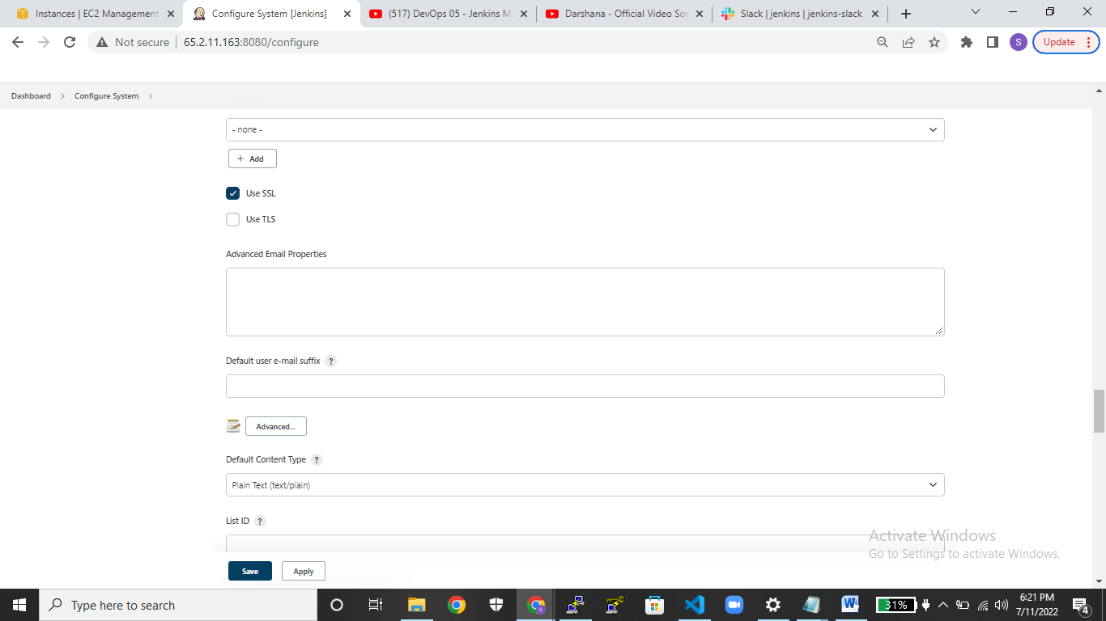  
  
** click on default triggers select the options whatever do you want finally click on add?  
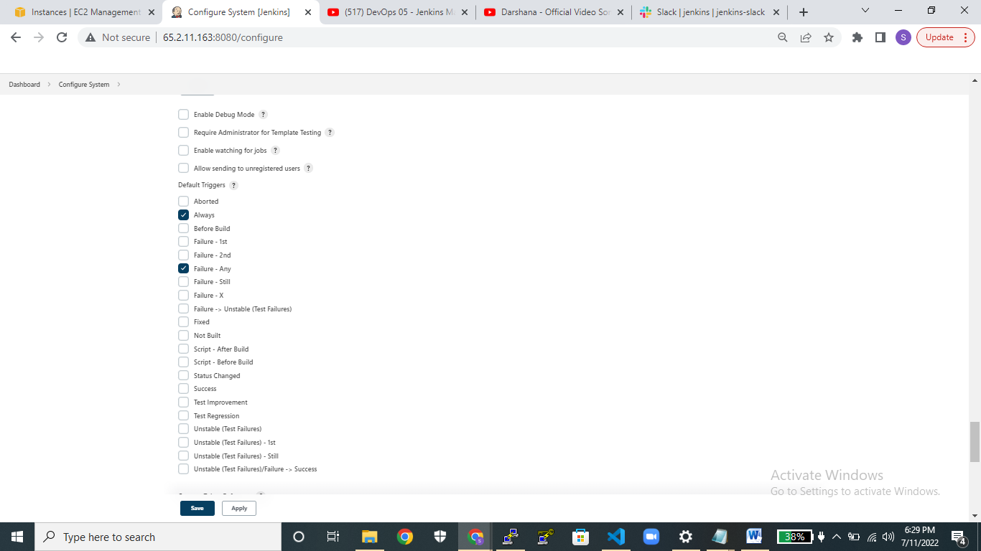  
  
**Second type of email notifications**:  
**step1:** provided smtp server as  
**smtp.gmail.com**  
 **step2: use smtp authentication username:** give gmail username **password**: give gmail password  
**step3**: checkbox the ssl  
**Step4**: provide smpt port as 465(gmail port no) click it on save button.  
  
  
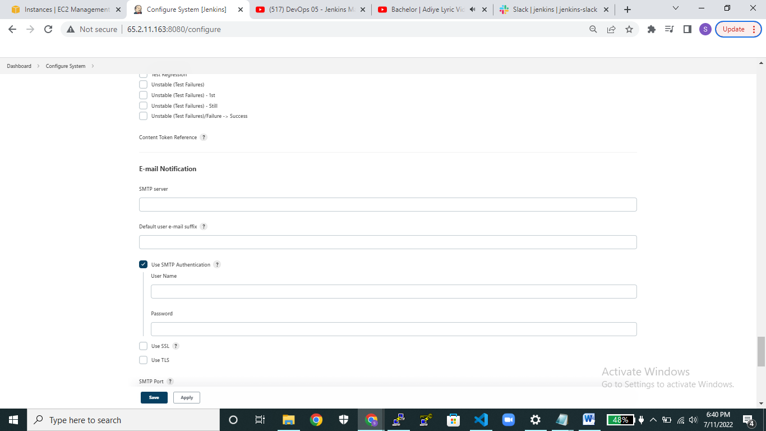  
  
  
 **Step5**: After creating a pipeline select postbulidaction over there select the option either editable email notification or email notification   
